

User Guide

November 2019



Real Life

Life Changing

Changing Healthcare



Real Life

Life Changing

Changing Healthcare

User Guide

December 2019



Copyright

NAVVIS Unified Ecosystem Experience (UEE) user guide release 1.00.

Copyright © 2019 NAVVIS & Company, LLC. All rights reserved.

Trademarks

The other product names mentioned may be trademarks of their respective owners.

Disclaimer

Sample names and persons used in this document are purely fictitious and do not refer to real names or persons.

This user's guide has been created with utmost care; nevertheless, it is not guaranteed that this document is error free.

No part of this document may be reproduced or transmitted in any form or by any means, electronic or mechanical, for any purpose, without the express written approval of Navvis & Company.

Table of Contents

1 Preface 4

1.1 About Navvis Coreo UEE 4

1.2 About Navvis & Company 4

1.3 Purpose of this Document 4

1.4 Intended Audience 4

1.5 Organization of the Document 5

1.6 Document Conventions 5

Unified Ecosystem Experience (UEE)—User Function 6

1 Coreo UEE Overview 7

2 User Onboarding 8

2.1 Log into UEE—First Time User 9

2.2 About Locked Navvis-Okta SSO Account 13

2.3 Reset a Forgotten or Expired Password 14

3 UEE Panel View—Screen Layout and Navigation 15

3.1 Toolbar Elements 16

3.2 Panel Elements 17

4 Display Settings for UEE Panel View 17

4.1 Display Settings Window—Layout and Navigation 18

5 Configuring a Single Panel Mode 24

5.1 Create a Single Panel View 24

6 Creating Presets for Multi-Panel Mode 27

6.1 Configure a Double Panel View 27

6.2 Save a Double Panel Configuration as a Preset 29

6.3 Pin A Double Panel Preset to The Toolbar 34

6.4 Configure a Triple Panel View 34

6.5 Save a Triple Panel Configuration as a Preset 34

6.6 Pin A Triple Panel Preset to The Toolbar 34

6.7 Switching Between Single Panel View and Multi-Panel View 34

6.8 Switching Between Double Panel View and Triple Panel View 34

7 Editing the Presets and Toolbar Preferences 34

7.1 UI Elements on the Edited Toolbar 34

7.2 Pin an Application to the Toolbar 34

7.3 Pin a Preset to the Toolbar 34

7.4 Apply a Coreo Application to the Screen 34

8 Panel Formats and Screen Resolutions 34

8.1 Panel Formats in Standard View and Widescreen View 34

8.2 Screen Resolutions for Optimal Display of Pinned Applications and Presets 34

9 Viewing Synchronized Patient Records 34

9.1 Synchronize Patient Records Across Applications in Panel View 34

10 Appendices 35

11 Glossary 36

12 Index 37

# Preface

Welcome to the release of the NAVVIS Coreo UEE (Unified Ecosystem Experience) user guide.

## About Navvis Coreo UEE

The UEE application supports the display of other Coreo ecosystem applications such as Coreo View, Coreo Home, and Coreo Analytics in a single-panel view for standard screens and wide screens, and in multi-panel view for wide screens.

The user can configure all those applications available through the Navvis-Okta SSO account to view on the UEE screen.

The Coreo ecosystem includes the following applications as illustrated below:

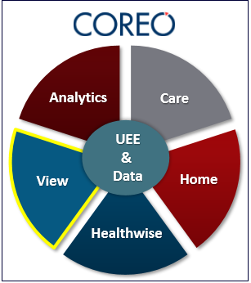

UEE allows its users to configure an application and to view it in a single panel or configure multiple applications to view them in multiple panels on their device screens, with each application assigned to a panel.

## About Navvis & Company

Navvis & Company provides counsel to health systems, hospitals and physician groups on the development of innovative, market-linked strategies to build future-ready health systems, cultivate tomorrow’s leaders and strengthen strategic performance.

## Purpose of this Document

This guide is the primary source of information about Navvis Unified Ecosystem Experience. It contains overviews, processes, and procedure to use the Unified Ecosystem Experience application effectively.

## Intended Audience

1. The regular users of the Unified Ecosystem Experience application who include the following personnel:

* Clinical staff and hospital administrators
* Employees, consultants, contractors or agents of the clinicians or patients who have been invited by the clinician or patient to access and use the service to participate in the care of the patient.
* Any other person or entity involved in the care of the patient including patient's care providers, patient's insurer or payer, or a social worker, or government agencies.

1. Unified Ecosystem Experience administrator users who are assigned the task of managing the regular users of the Unified Ecosystem Experience application

## Organization of the Document

This document contains the following modules:

* Module 1, “User onboarding”
* Module 2, “UEE panel view—Screen layout and navigation”
* Module 3, “Display settings for UEE panel view”
* Module 4, “Creating presets for single panel format”
* Module 5, “Creating presets for multi-panel format”
* Module 6, “Editing the toolbar”
* Module 7, “Panel formats and screen resolutions”
* Module 8, “Synchronizing patient records”

## Document Conventions

This document uses the following conventions:

| Convention | Item |
| --- | --- |
| **boldface** font | **Menu** items, **Tab** names, **Text** **box** names, **List** **box** names, **Button** names and **Navigation** paths |
| Text in blue | Hyperlinks |
|  | Note: Notes contain helpful suggestions. A note will inform the reader about any deviation in the sequence of instructions or helps the reader save time in understanding why something is not working. |
|  | Tip: The information will help the user solve a problem faster, or to perform an action in a different way. |
|  | Caution alerts the reader to avoid doing something that could result in loss of data or any other damage. |

Unified Ecosystem Experience (UEE)—User Function

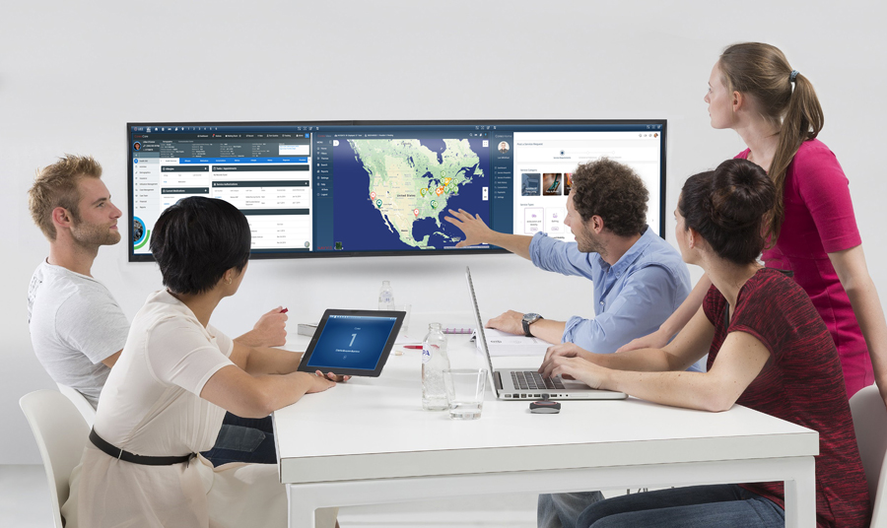

# Coreo UEE Overview

Coreo UEE provides the convenience of viewing all the applications available through the Navvis-Okta SSO account that the users have access to on standard screens and wide screens either in a single panel mode or in a multi-panel mode.

The following illustration gives an overview of the UEE application:

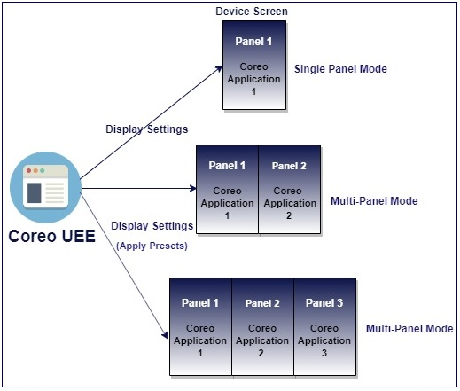

1. Coreo UEE Overview

Use the display settings feature in UEE to do the following:

* Configure the device screen to view the applications either in a single panel mode or in a multi-panel mode.
* Change the toolbar preference on the UEE screen to pin the applications and presets so that the user can apply the required configurations to the screen easily.

# User Onboarding

A first-time user of Unified Ecosystem Experience (UEE) receives an automated email verification link from the Okta system administrator to activate the Okta account.

The Okta Single Sign-On(SSO) service provides a single secure home page to log into the UEE application and other applications that are part of the Coreo ecosystem.

As a user, you can access only those Coreo applications for which you have permission for and based on the role assigned to you by your system administrator.

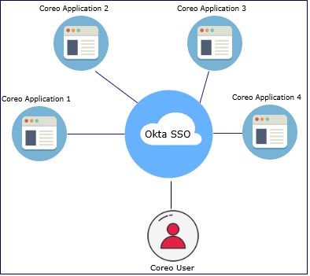

1. Okta Single Sign On (SSO) for Coreo applications

## Log into UEE—First Time User

Follow these steps to activate the Navvis-Okta SSO account to access the Unified Ecosystem Experience application:

1. Open the email link sent to your email inbox by the Okta administrator.



1. Email Notification
2. Select the ActivateAccLinkGreenBox.png link. The **Create your Navvis account** screen opens.

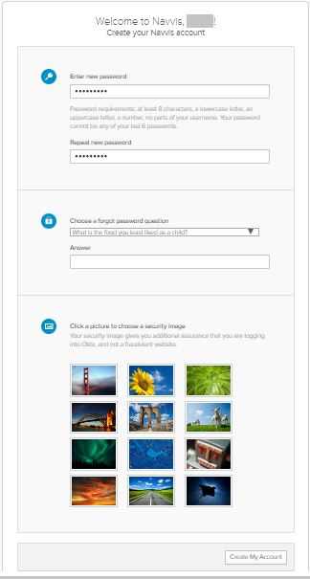

1. Create Your Navvis Account Screen
2. Enter the new password in **Enter new password**. The password must be at least 8 characters long and a maximum of 25 characters.

The password must be a combination of these following characters:

| Description | Characters |
| --- | --- |
| Upper case characters | A – Z |
| Lower case characters | a – z |
| Digits | 0 – 9 |
| Special characters | ~ ! @ # $ % ^ & * _ - + = ` | \ () {} [] : ; " ' < > , . ? / |

1. System Accepted Password Characters
2. Reenter the password in the **Repeat new password** box.
3. The user must add a security question to reset a new password in the scenario where user may forget the password during the future use.
4. Under **Choose a forgot password** question, select the arrow to view the questions.



1. Choose A Forgot Password Question in the Create Your Navvis Account Screen
2. Choose a security question from the list.
3. In the **Answer** box, enter the answer. You must remember this answer because it is used at a later date to reset a forgotten or expired password.
4. Choose a picture as a security image in the **Create your Navvis account** screen and then select **Create My Account**.

|  |  |
| --- | --- |
|  | The security image displays in the NAVVIS Sign In screen on entering the user name. |

1. The **Navvis** landing screen opens.

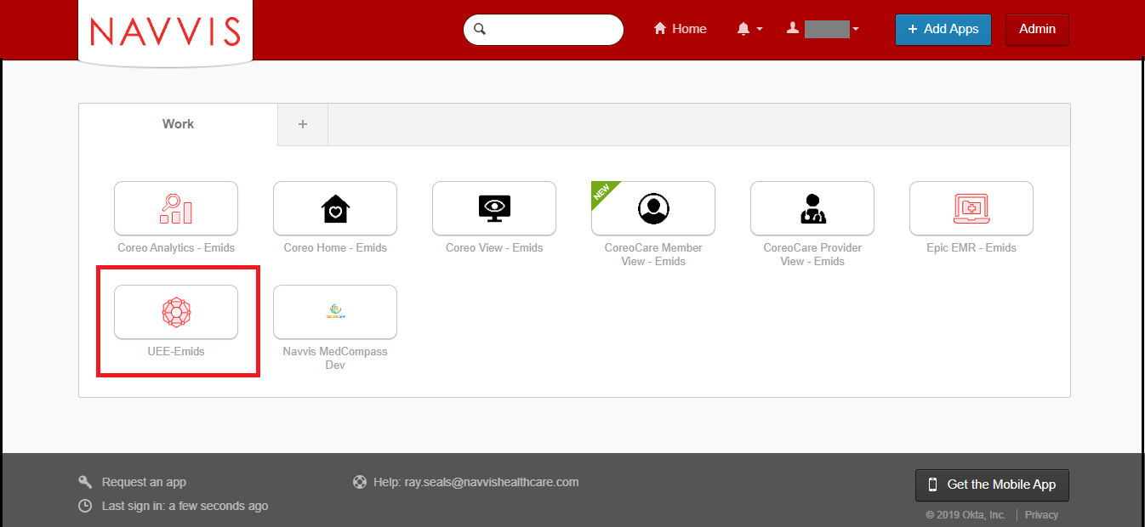

1. NAVVIS Landing Screen
2. Select the **UEE - Emids** button on the landing screen. The Coreo applications that you see on the Navvis landing screen depends upon the user role and permissions assigned to you by your NAVVIS system administrator.
3. The **NAVVIS Sign in** screen opens.

|  |  |
| --- | --- |
|  | Once the user accepts EULA and the Navvis-Okta SSO account is activated, the new user becomes an existing user.  As an existing user, go to [navvis.oktapreview.com](https://navvis.oktapreview.com/) to open the NAVVIS Sign in screen. |



1. NAVVIS Sign In Screen
2. Enter the user ID in the **Username** box.
3. Enter the password in the **Password** box. The password must be at least 8 characters long and a maximum of 25 characters.
4. Select **Sign In**.
5. The EULA screen displays for a first-time user of UEE. A first-time user of UEE is required to accept the EULA (End User License and Business Associate Agreement) before accessing the UEE application.

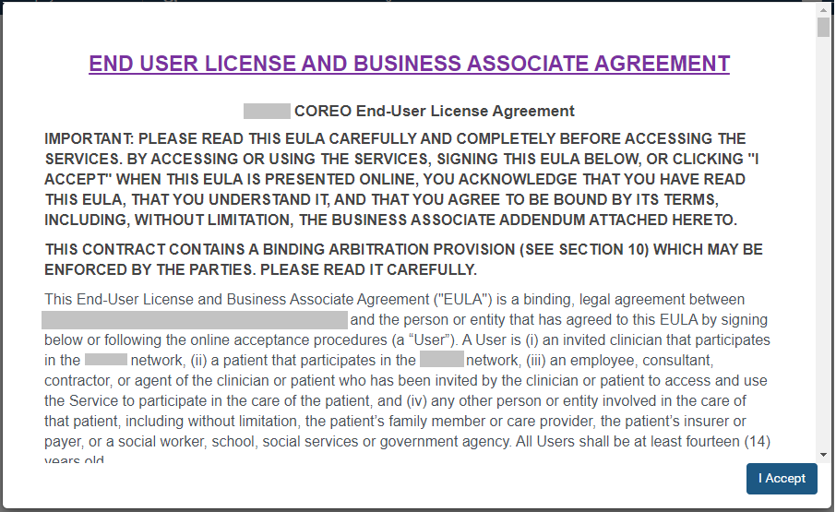

1. EULA PAGE
2. Read the terms and conditions and select the **I Accept** button. Your NAVVIS account is activated successfully and the UEE home page opens.

## About Locked Navvis-Okta SSO Account

The Navvis-Okta SSO account locks for the following reasons:

* The user exceeds five failed login attempts within 24 hours. The login attempts fail when the user enters an incorrect password.

The locked account resets after 24 hours and the user can log in to the account after 24 hours without contacting the Okta system administrator.

|  |  |
| --- | --- |
|  | To unlock the NAVVIS account immediately after the five failed login attempts, contact the Okta system administrator. |

* The Okta system administrator can lock the NAVVIS-Okta SSO account as per the company lock account policy.

## Reset a Forgotten or Expired Password

The Okta Single Sign-On password policy specifies that the password expires after 60 days, and the user must reset the password periodically.

Also, if the user forgets the password, Navvis-Okta gives the option to reset the password.

Follow these steps to reset the password:

1. Go to [navvis.oktapreview.com](https://navvis.oktapreview.com/) to open the **Navvis Sign in** screen.



1. NAVVIS Sign In Screen—Forgot password? Option
2. Select the **Need help signing in?** drop-down list.
3. Select the **Forgot password?** option to open the **Reset Password** screen.



1. Reset Password Screen
2. Enter the e-mail or the user name in the **Email or Username** box.
3. Select **Reset via E-mail**. The user can reset the password using the verification link sent to the user’s email address.
4. Reset the password with the following considerations:

* The new password cannot be among the previous six passwords.
* The password expires after 60 days and the user must reset the password periodically.
* The user will be locked out of the application after five failed login attempts. The login attempts fail when the user enters an incorrect password. Contact the Okta administrator to reset the password.

On the successful resetting of the password, the new password is reset for the Navvis-Okta Single Sign-On account.

# UEE Panel View—Screen Layout and Navigation

The screen layouts in the UEE application are similar in appearance. However, a few user interface elements differ depending upon the following reasons:

* The number (one, two or three) of panels that are displayed on the screen
* The type of user login — a first time user of UEE or an existing user
* The user’s role and permissions

The following figure is the default screen view of the UEE application when the user logs into the application as a first time user.

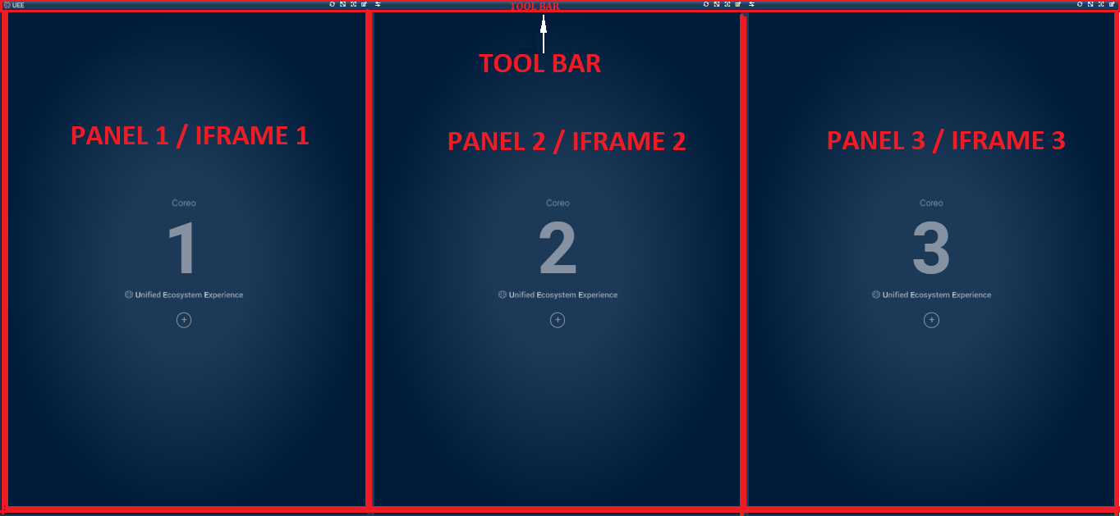

1. UEE Screen—Triple Panel View

The UEE home page layout includes the following areas:

* Toolbar: Includes buttons to apply the presets to the panels, to access the display settings for the panel, and to control the magnification settings of the panel screen.
* Panel: Each Coreo application can be assigned to a panel and can have a maximum of three panel on the device screen.

Toolbar Elements

The toolbar runs across all the three panels on the UEE screen. The **Refresh** button, the **Maximize Display** button, the **Help** button, and the **Display** **Settings** button are available for each panel. These buttons are located in the upper-right corner of the panel on the toolbar.

The **Swap** button is located in the upper-left corner of the second panel and third panel on the toolbar.

Refer to the following table to view details about the elements on the tool bar.

| Icon | Element name | Description |
| --- | --- | --- |
|  | **UEE** Logo | The UEE logo |
|  | **Refresh** button | Use this to refresh the Coreo application of that panel. |
|  | **Maximize Display** toggle button | Use this button to enlarge the panel layout view to fit the entire screen of the device. Select the same button or select **Esc** on the keyboardto exit the full screen. |
|  | **UEE Help** button | Use this button to open the UEE user help document. |
|  | **Display Settings** button | Use this button to open the **Display Settings** pop-up window. In the pop-up window, you can create, modify, or delete presets. You can also pin a Coreo application or a preset to the tool bar using this window. |
|  | **Swap** button |  |

1. Toolbar—UI Element Names

## Panel Elements

Refer to the following table to view details about the elements in the panel.

| Icon and Element Name | Description |
| --- | --- |
| Panel 1 | The first panel.  The UEE screen can display a maximum of three panels on the device screen. The first panel is the Left (**L**) panel. |
| Panel 2 | The second panel.  The second panel is the Central (**C**) panel. |
| Panel 3 | The third panel.  The third panel is the Right (**R**) panel. |
| **Display Settings** button | Use this button to open the **Display Settings** pop-up window. You can click anywhere in the panel area to open the **Display** **Settings** window. |
| UEE logo | The UEE logo |

1. Panel—UI Elements Names

# Display Settings for UEE Panel View

Use the display settings feature in UEE to configure the following modes on your device screen:

* Single panel mode: You can configure a Coreo application to view it in a single panel layout. The single panel mode is available on standard screens and wide screens.
* Double panel mode (Multi-panel mode): You can configure the Coreo applications to view them in a double panel layout, with each application assigned to a panel. The double panel mode is compatible with widescreens only. You can save the configurations of a double panel mode as presets.
* Triple panel mode (Multi-panel mode): You can configure the Coreo applications to view them in a triple panel layout, with each application assigned to a panel. The triple panel mode is compatible with wide screens only. You can save the configurations of a triple panel mode as presets.

UEE also allows its users to pin the Coreo applications and presets on the toolbar of the UEE screen to access and apply the screen configurations easily.

## Display Settings Window—Layout and Navigation

UEE provides the flexibility to configure different Coreo applications to view in different panels on the device screen.

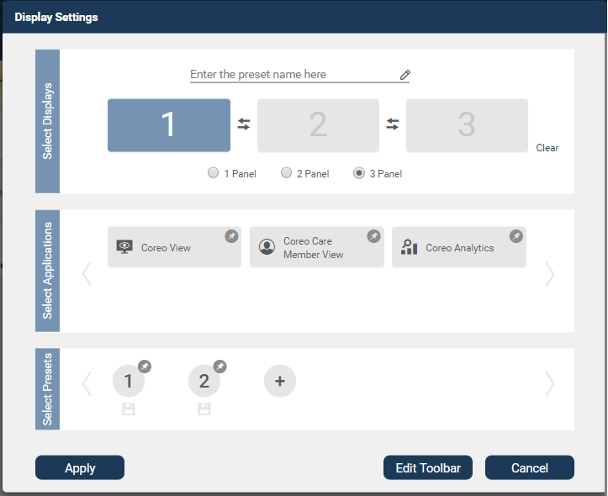

1. Display Settings pop-up window

Refer to the following table to view details about the elements in the **Display** **Settings** window.

| Icon and Element name | Description |
| --- | --- |
| **Select Displays** group | In this group, do the following:   * Select the number of panels to display on the device screen. * Swap the applications between the panel slots when configuring the applications for a double panel view and a triple panel view. * Delete the applications assigned to the panel slots using the **Clear** button. |
| 1 Panel slot | Use this slot to assign a Coreo application to the first panel on your display screen.  In a single panel view, you can display the Coreo application either in the left panel, or in the central panel or in the right panel. |
| First panel slot–Empty and Highlighted | An empty panel slot. When the user selects a panel slot, it highlights to blue. |
| First panel slot–Assigned | A panel slot with an application assigned to it. |
| **L C R** position buttons | Use these buttons to position the application view either in the (**L**) left panel, or in the (**C**) central panel or in the (**R**) right panel on the device screen.  These buttons are available only when you select the **1 Panel** button. |
| **2 Panel** slot | Use this slot to assign a Coreo application to the second panel on your display screen.  In a 2 panel mode, you can assign an application each to both panel 1 and panel 2. |
| Second panel slot–Empty and Highlighted | A selected panel slot to which an application can be assigned. |
| Panel slot–Non-Highlighted | A cleared panel slot. |
| **3 Panel** slot | Use this slot to assign an application to the third panel on your display screen.  In a 3 panel mode, you can assign an application each to panel 1, panel 2 and panel 3. |
| Third panel slot–Empty and Highlighted | A selected panel slot to which an application can be assigned. |
| Swap button | Use this button to swap the Coreo applications between the panel slots when configuring the applications for a double panel view and a triple panel view.  The swap button between panels 1 and 2 interchanges the applications between panel 1 and panel 2.  The swap button between panels 2 and 3 interchanges the applications between panel 2 and panel 3. |
| **Clear** button | Use this button to delete the applications that are assigned to the panel slots. |
| Panel button group | In this button group, select the number of panels to display on the device screen. |
| **1 Panel** button | Select this button to display the application in a single panel on the device screen. |
| **2 Panel** button | Select this button to display the applications in a double panel on the device screen, with each application configured to a panel. |
| **3 Panel** button | Select this button to display the Coreo applications in a triple panel on the device screen, with each application configured to a panel. |
| **3 Panel** button–Selected | A selected radio button |
| Preset name box | Enter the name of the preset in this box to save the preset and apply it to the device screen.  You can save only double panel and triple panel configurations as presets. |
| **Select Applications** group | In this group, do the following:   * Select the application to assign to the panel slot. * Pin the applications to the toolbar of the UEE screen using the **Edit Toolbar** button in the lower-right corner of the **Display Settings** window. |
| Application slots | The applications to assign to the **1 Panel** slot to configure a single panel mode.  **Coreo View** – **Prioritized View**, **Coreo** **View – Bed View**, and **Coreo View – Geomap View** applications are available for 1 panel slot only. |
| Application slot–blue | A selected application.  An application that is assigned to a panel slot. |
| Pin icon–blue | A pinned application.  An application that is pinned to the toolbar of the UEE panel screen. |
| Application slot–grey | An application that is not assigned to a panel slot for a given configuration. |
| Pin icon–grey | A non-pinned application.  An application that is not pinned to the toolbar of the UEE panel screen. |
| Application slots | The applications to assign to the **2 Panel** slots and **3 Panel** slots to configure double panel mode and triple panel mode, respectively. |
| Left Chevron icon | Use this to navigate to the left and access the applications that are not within the default view of the **Display Settings** window. |
| Right Chevron icon | Use this to navigate to the right and access the applications that are not within the default view of the **Display Settings** window. |
| **Select Presets** group | In this group, do the following   * Save the configurations as presets to apply to the UEE panel screen for a double panel mode and a triple panel mode. * Pin the applications to the toolbar of the UEE screen using the **Edit Toolbar** button in the lower-right corner of the **Display Settings** window. |
| Preset icon | A saved preset. A configuration can be saved as a preset for a 2 panel or a 3 panel view only. |
| Pin icon–grey | A non-pinned preset.  A preset that is not pinned to the toolbar of the UEE panel screen. |
| Pin icon–blue | A pinned preset.  A preset that is pinned to the toolbar of the UEE panel screen. |
| Preset icon–blue | A highlighted preset.  The configuration of a highlighted preset is displayed in the **Display** **Settings** window. |
| Save button | Use this to save the preset. |
| Add Preset button | Use this button to create a new preset. A configuration can be saved as a preset for a 2 panel or a 3 panel view only. |
| **Apply** button | Use this button to apply a single panel configuration or presets to the UEE panel screen. |
| **Edit Toolbar** button | Use this button to edit the toolbar of the UEE panel screen. You can pin the applications and presets to the toolbar. |
| **Cancel** button | Use this button to close the **Display** **Settings** window. |

1. Display Settings Window—UI Element Names

# Configuring a Single Panel Mode

Single panel mode

## Create a Single Panel View

Follow these steps to configure a single panel view on the UEE screen of your device:

1. Click the UEE application on the Navvis Landing screen to open the UEE screen.

|  |  |
| --- | --- |
|  | For a first time user of the UEE application, a blank triple panel layout is displayed as the default screen view. If you are an existing user, the panel view configuration that you last saved during your previous login session is displayed on the UEE screen. |

1. Select the **Display** **settings** button or click anywhere in the blank panel frame to open the **Display** **Settings** window.
2. In the **Select** **Displays** group, select the **1 Panel** radio button. A single panel slot displays.

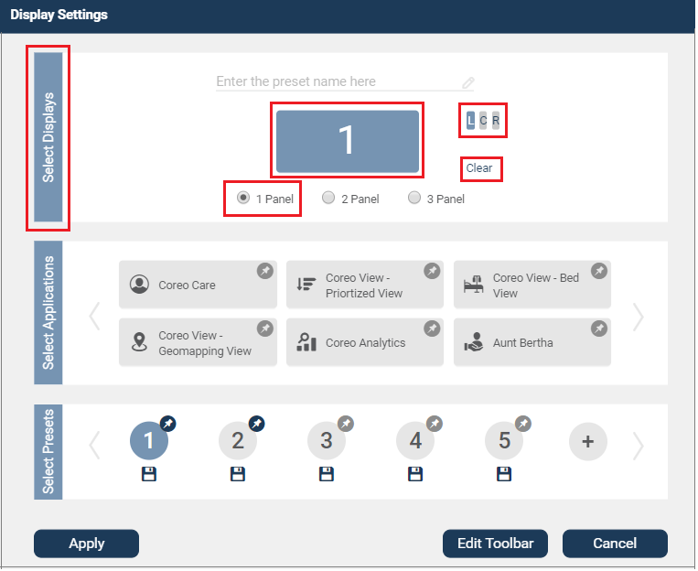

1. Display Settings Window—1 Panel Slot

|  |  |
| --- | --- |
|  | If you switch from the 2 Panel or 3 Panel to the 1 Panel button, an existing application that is already assigned to the first Panel diplays in the Panel 1 slot. You can use the Clear button to clear the Panel 1 slot to reassign another application. |

1. In the **Select** **Applications** group, select the application to assign to the single panel slot.

For a single panel slot, the Coreo View application under the **Select Applications** group is available in three views, **Coreo View-Prioritized View**, **Coreo View-Bed View** and **Coreo View-Geomapping View**.

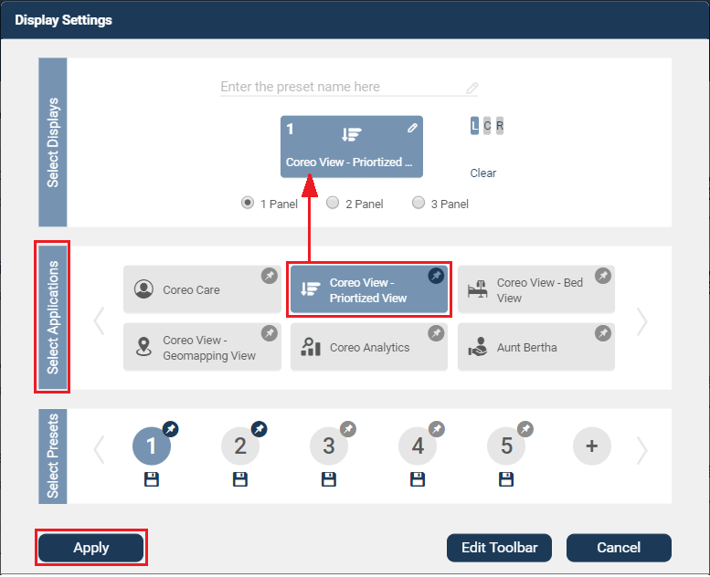

1. Display Settings Window—Assigning an Application
2. Click the **Apply** button to apply the single panel configuration to the UEE screen on your device. The default position of the configured panel is on the left (**L**) side of the device screen.

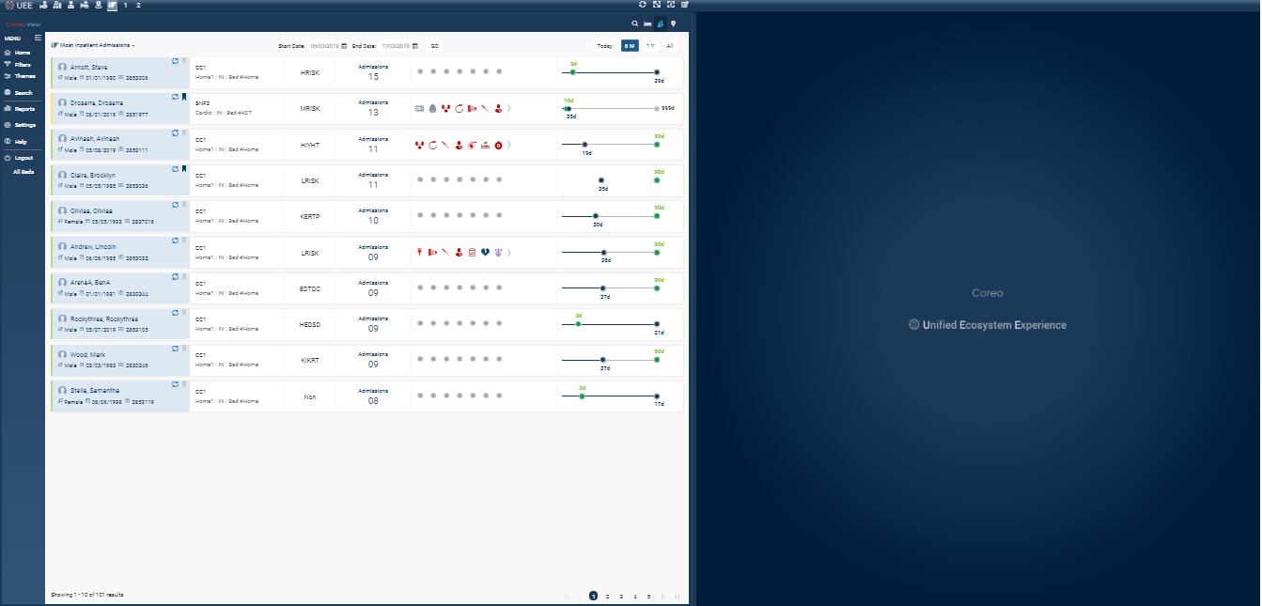

1. Device Screen in Single Panel Mode—Left (L) Position
2. To position the configured panel at the center of the screen, click the **C** button in the **Display** **Settings** window and then click the **Apply** button.

The configured panel is displayed in the middle of the device screen.

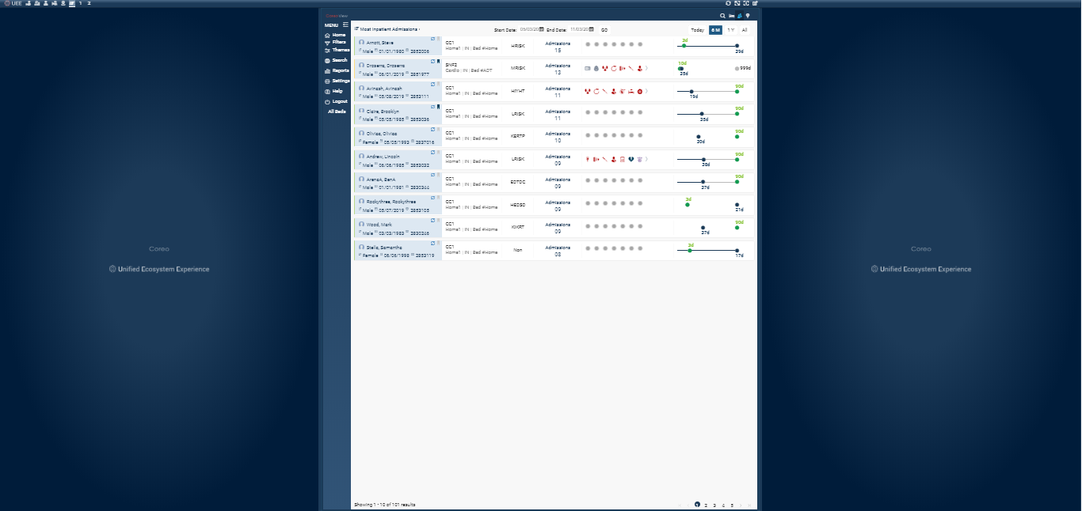

1. Device Screen in Single Panel Mode—Center (C) Position
2. To position the configured panel on the right side of the screen, click the **R** button in the **Display** **Settings** window and then click the **Apply** button. The configured panel displays on the right side of the device screen.

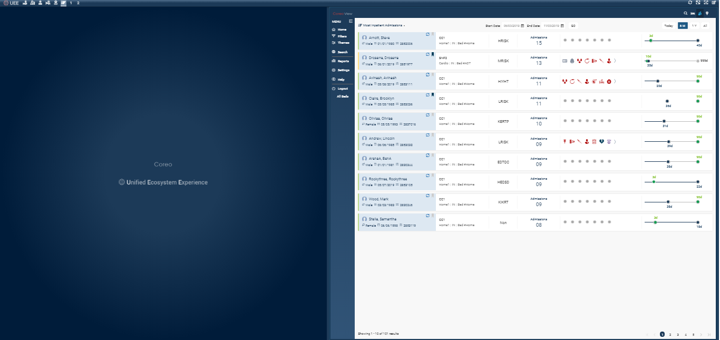

1. Device Screen in Single Panel Mode—Right (R) Position

When you assign the **Coreo View-Bed View** application to the single panel slot in the **Display Settings** window and apply the configuration to the screen, the configured panel with the Bed view application stretches across the entire width of the device screen.

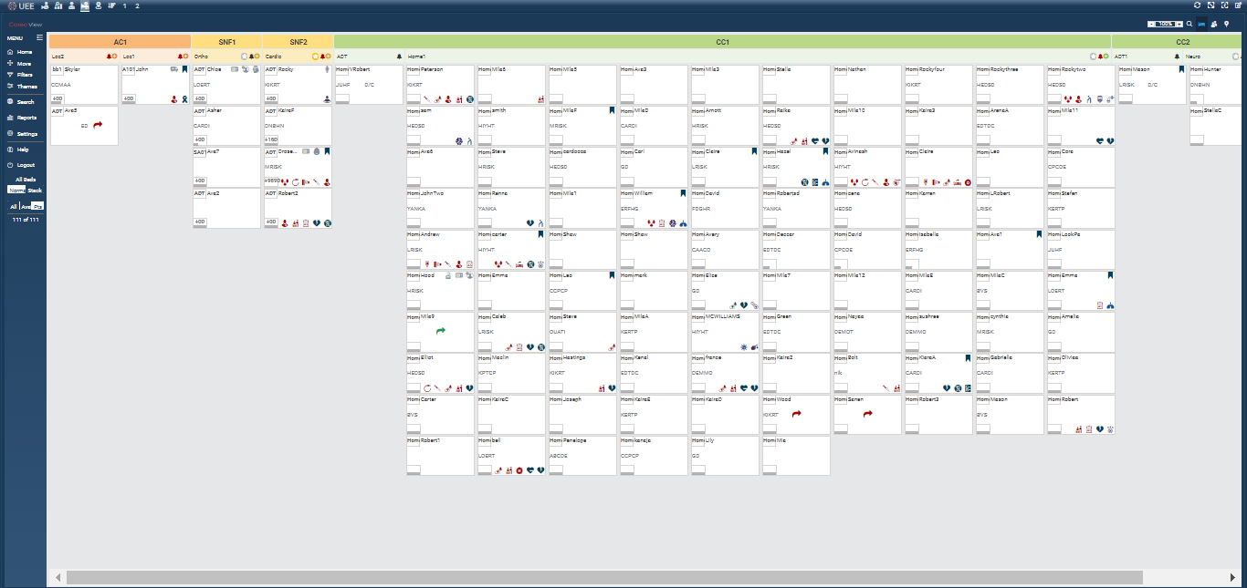

1. Device Screen in Single Panel Mode—Bed View Applicaion

Similarly, when you assign the **Coreo View-Geomap View** application to the single panel slot in the **Display Settings** window and apply the configuration to the screen, the configured panel with the Geomap view application stretches across the entire width of the device screen.

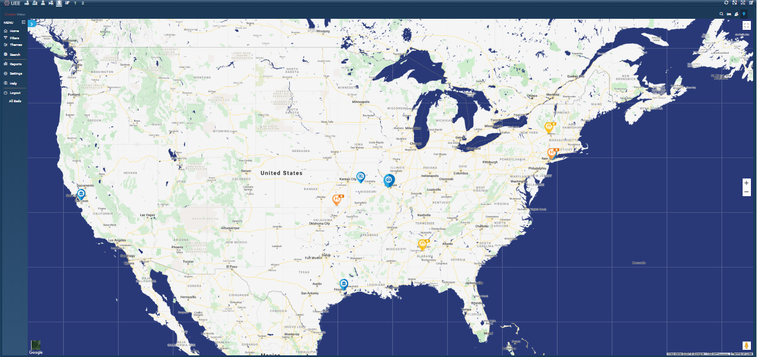

1. Device Screen in Single Panel Mode—GeoMapping View Applicaion

# Creating Presets for Multi-Panel Mode

Intro

## Configure a Double Panel View

Follow these steps to configure a double panel view in the **Display** **Settings** window and apply it on the UEE screen of your device:

1. Click the UEE application on the **Navvis Landing** screen to open the UEE screen.
2. Select the **Display** **settings** button or click anywhere in the blank panel frame to open the **Display** **Settings** window.

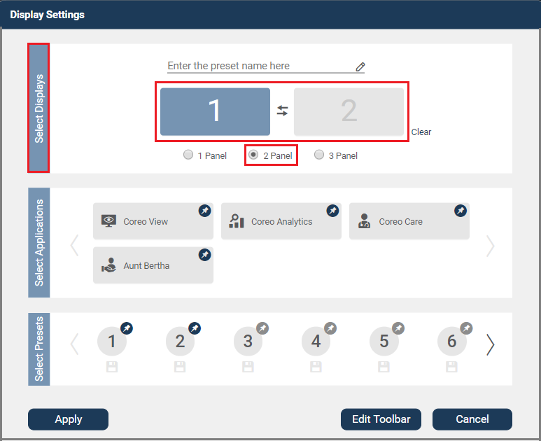

1. Display Settings Window—2 Panel Slot
2. In the **Select** **Displays** group, select the **2 Panel** radio button. A two panel slot displays.
3. Select the first panel and in the **Select** **Applications** group select the application to assign to the selected panel slot.

You can use the **Clear** button to clear the panel slots to reassign the applications if the panel slots have preassigned applications.

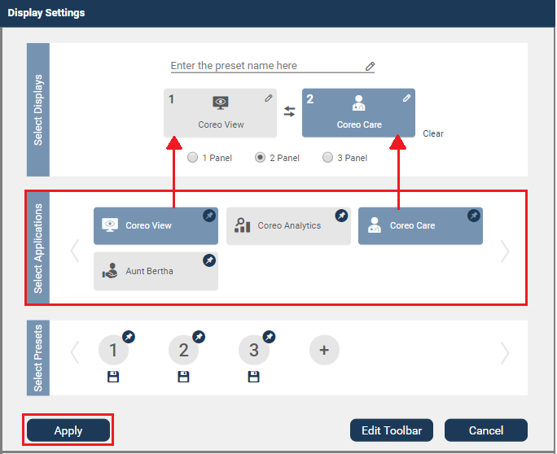

1. Display Settings Window—Assigning Applications to Panel Slots
2. Select the second panel and in the **Select** **Applications** group select the application to assign to the selected panel slot.

If you choose to interchange the assigned applications between the panel slots, you can use the swap button . For example, if you have assigned the Coreo View application to panel 1 and Coreo Care application to panel 2 and if you click the Swap button, then the Coreo View application that was assigned to panel 1 is now assigned to panel 2 and Coreo Care application to panel 1.

|  |  |
| --- | --- |
|  | UEE gives you the flexibility to select the panel slots in the order of your choice when assigning the applications; you can either select panel 1 or panel 2 first when assigning the application. |

1. Click the **Apply** button to apply the double panel (2 panel) configuration to the UEE screen on your device.

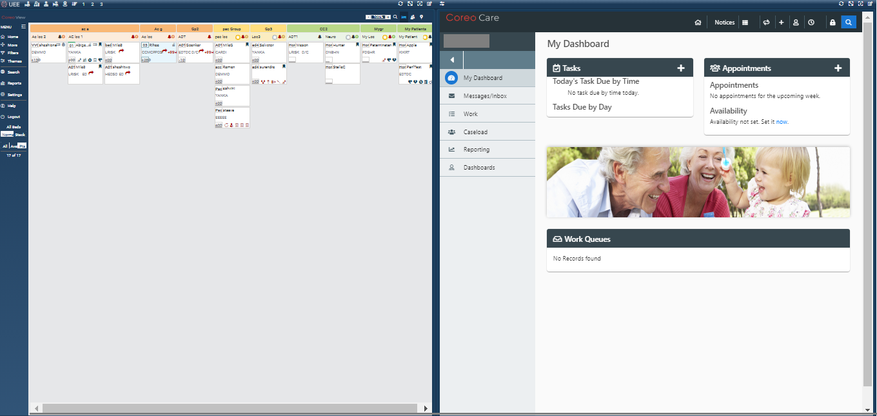

1. Device Screen in Double Panel Mode

## Save a Double Panel Configuration as a Preset

UEE gives the provision to save a double panel configuration as a preset. Saving presets help you to store the most frequently used configurations for later use.

Follow these steps to save a double panel (2 Panel) configuration as a preset:

1. Select the **Display** **settings** button or click anywhere in the blank panel frame to open the **Display** **Settings** window.
2. Click the Add Preset button in the **Select Presets** group.

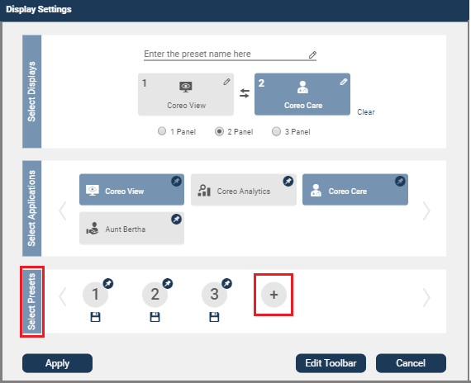

A new preset icon is created with the preset number auto generated by UEE.

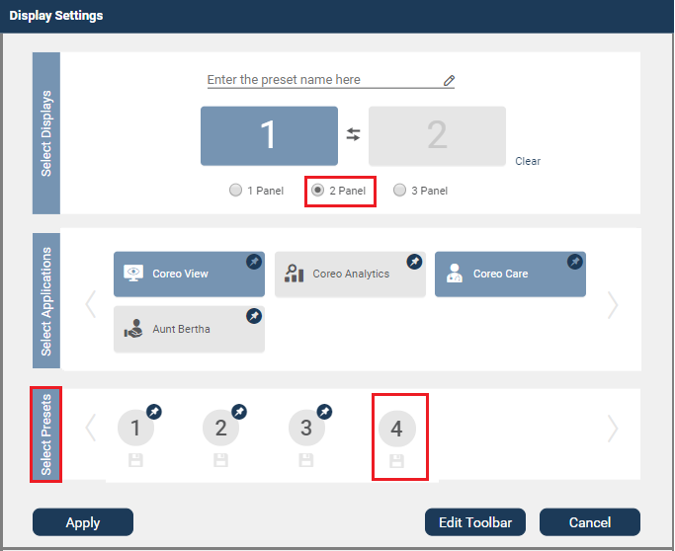

1. Select the **2 Panel** radio button in the **Select Displays** group.
2. Select the first panel slot and in the **Select** **Applications** group select the application to assign to the selected panel.

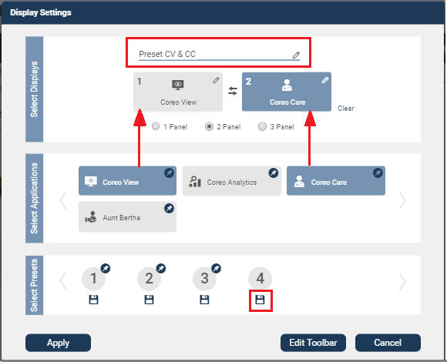

1. Creating a Preset
2. Select the second panel slot and in the **Select** **Applications** group select the application to assign to the selected panel.
3. Enter the preset name in the **Enter the preset name here** box. This preset name displays as a tooltip to the pinned preset on the toolbar. You can also the enter the preset name before assigning the applications to the panel slot.
4. Click the Save button below the preset icon in the **Select** **Presets** group to save the double panel configuration as a preset.

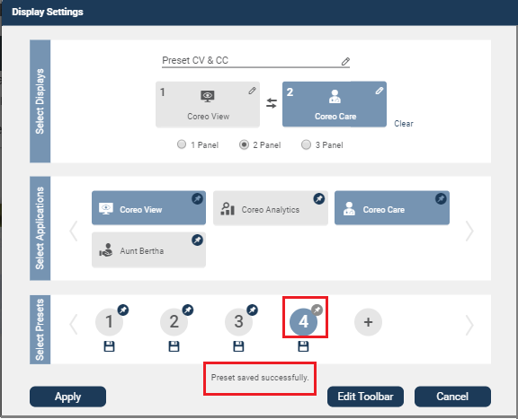

1. Saving a Preset

On saving the preset, a message, “**Preset saved successfully**” displays indicating that the preset has been saved successfully. A grey pin icon displays with the saved preset, and you can pin this preset to the toolbar.

1. Click the **Apply** button to apply the saved preset to the device screen with immediate effect or, click the **Cancel** button to exit the **Display** **Settings** window without applying the saved preset, however, to use it when required.

## Pin a Double Panel Preset to the Toolbar

You can customize the toolbar by pinning presets to it. This helps you to switch between presets and apply the required preset to the screen quickly.

Follow these steps to pin a double panel (2 Panel) preset to the toolbar:

1. Select the **Display** **settings** button or click anywhere in the blank panel frame to open the **Display** **Settings** window.

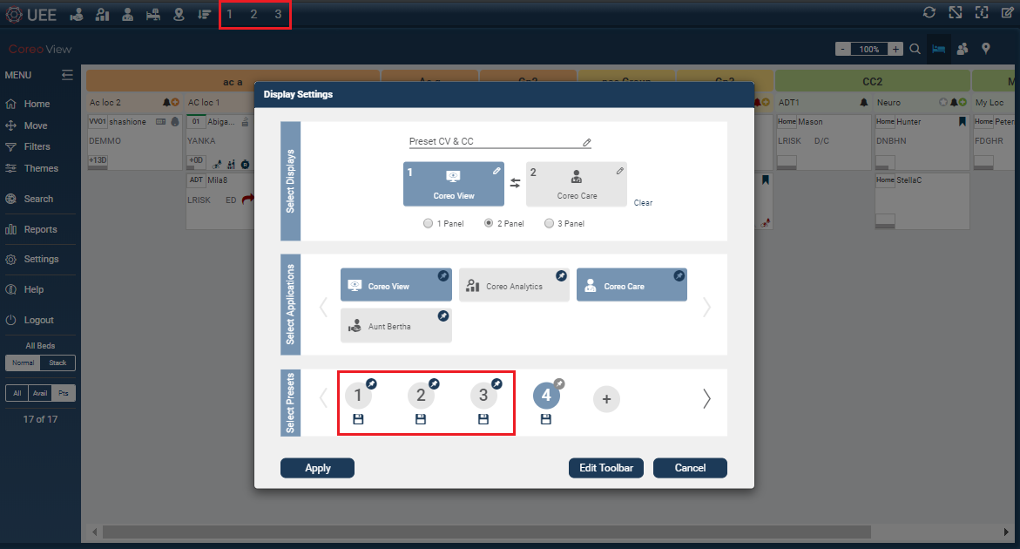

1. Presets Pinned to the Toolbar

The presets that are already pinned to the toolbar have blue colored pin icons and the presets that are not pinned to the toolbar have grey colored pin icons.

1. Click the **Edit Toolbar** button.
2. Select the preset with grey colored pin icon to pin it to the toolbar of the UEE screen.

The selected preset displays a blue color pin indicating that the preset is pinned to the toolbar.

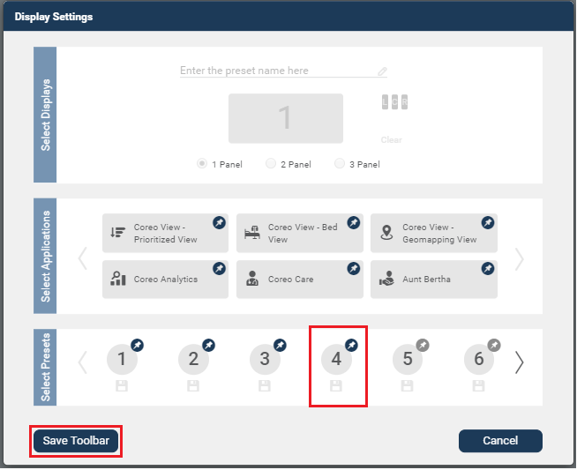

1. Pinning a Preset
2. Click the **Save** **Toolbar** button to save the changes that you made to the toolbar.

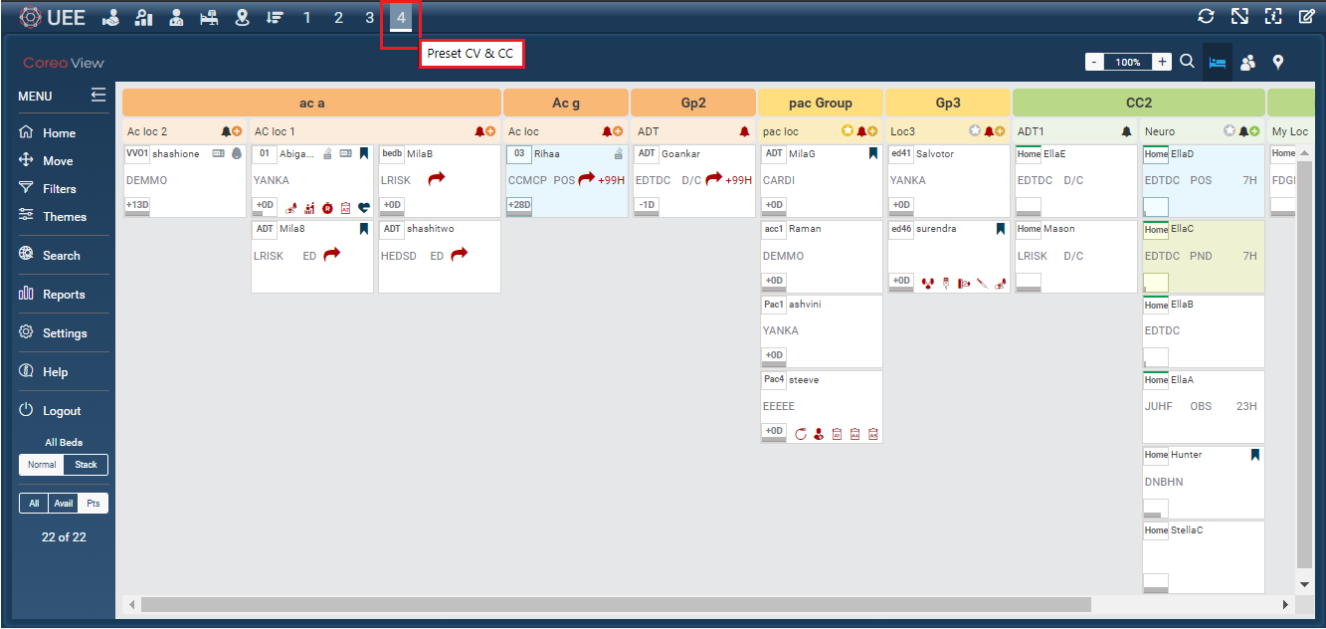

1. Preset Pinned to the Toolbar and Highlighted

The pinned preset is displayed on the toolbar. If the preset that is applied to the screen happens to be one of the pinned presets, the preset icon highlights on the toolbar with a thin white bar below the preset number.

If you hover the mouse over the pinned preset icon, the preset name that you had defined in the **Display Settings** window displays. Otherwise,

## Configure a Triple Panel View

Follow these steps to configure a triple panel view in the **Display** **Settings** window and apply it on the UEE screen of your device:

1. Click the UEE application on the **Navvis Landing** screen to open the UEE screen.
2. Select the **Display** **settings** button or click anywhere in the blank panel frame to open the **Display** **Settings** window.

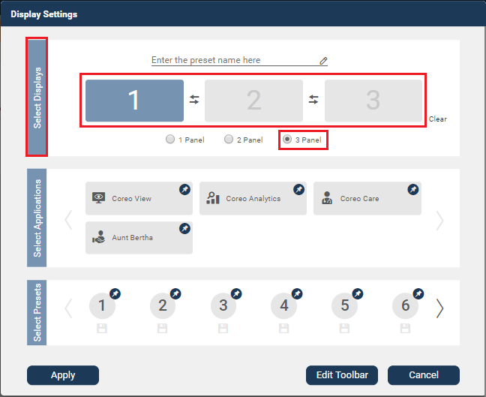

1. Display Settings Window—3 Panel Slot
2. In the **Select** **Displays** group, select the **3 Panel** radio button. A three panel slot displays.

You can use the **Clear** button to clear the panel slots to reassign the applications if the panel slots have preassigned applications.

1. Select the first panel and in the **Select** **Applications** group select the application to assign to the selected panel slot.
2. Similarly, select the second panel and third panel in the **Select** **Applications** group, and select the applications to assign to the selected panel slots.

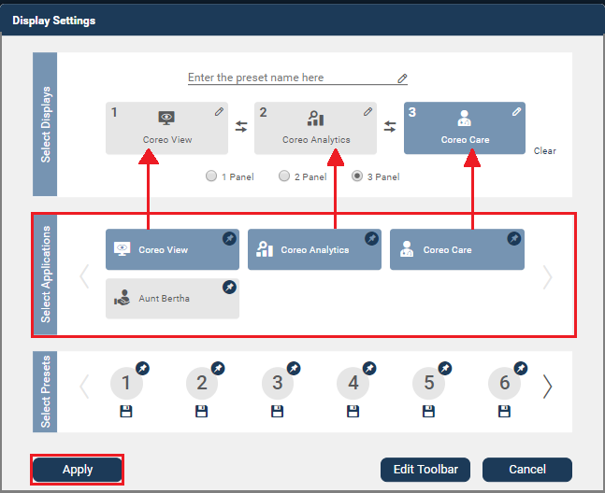

1. Display Settings Window—Assigning Applications to Panel Slots

If you choose to interchange the assigned applications between the panel slots, you can use the swap button . For example, if you have assigned the Coreo View application to panel 1 and Coreo Care application to panel 2 and if you click the Swap button, then the Coreo View application that was assigned to panel 1 is now assigned to panel 2 and Coreo Care application to panel 1. Similarly, you can swap the applications between panels 2 and 3.

|  |  |
| --- | --- |
|  | UEE gives you the flexibility to select the panel slots in the order of your choice when assigning the applications to them; you can select panel 1, panel 2 and panel 3 in any order when assigning the applications. |

1. Click the **Apply** button to apply the triple panel (3 panel) configuration to the UEE screen on your device.

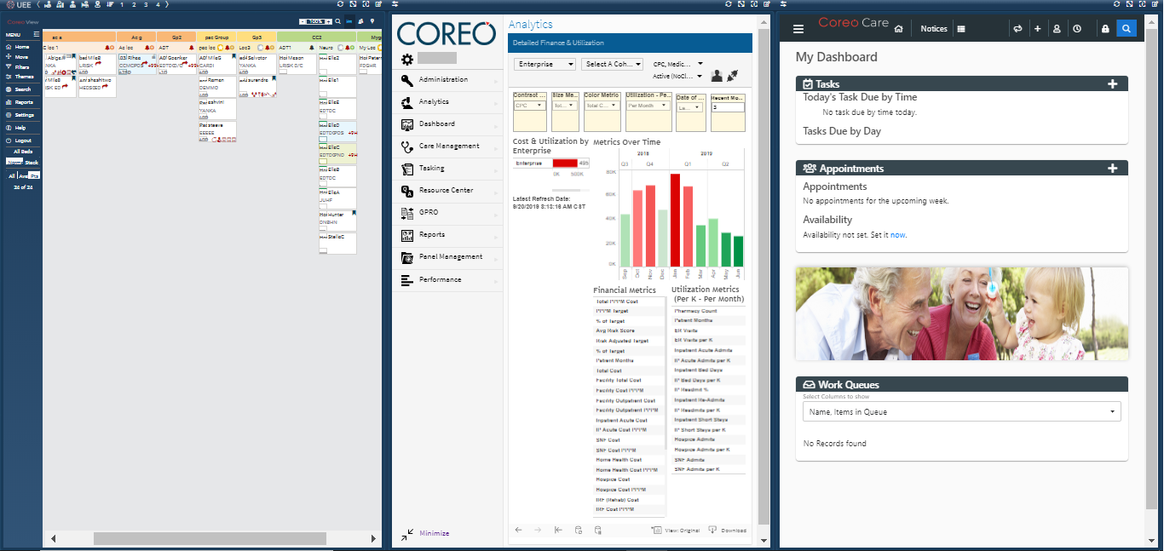

1. Device Screen in Triple Panel Mode

## Save a Triple Panel Configuration as a Preset

UEE gives the provision to save a triple panel configuration as a preset. Saving presets help you to store the most frequently used configurations for later use.

Follow these steps to save a triple panel (3 Panel) configuration as a preset:

1. Select the **Display** **settings** button or click anywhere in the blank panel frame to open the **Display** **Settings** window.
2. Click the Add Preset button in the **Select Presets** group.

## Pin A Triple Panel Preset to The Toolbar

## Switching Between Single Panel View and Multi-Panel View

## Switching Between Double Panel View and Triple Panel View

# Editing the Presets and Toolbar Preferences

## UI Elements on the Edited Toolbar

## Pin an Application to the Toolbar

## Pin a Preset to the Toolbar

## Apply a Coreo Application to the Screen

# Panel Formats and Screen Resolutions

## Panel Formats in Standard View and Widescreen View

## Screen Resolutions for Optimal Display of Pinned Applications and Presets

# Viewing Synchronized Patient Records

Synchronize Patient Records Across Applications in Panel View

Appendices

Credits

[www.navvishealthcare.com/](http://www.navvishealthcare.com/)

[www.linkedin.com/company/navvishealthcare](http://www.linkedin.com/company/navvishealthcare)

[www.pitchbook.com/profiles/company/88126-75](http://www.pitchbook.com/profiles/company/88126-75)

[www.crunchbase.com/organization/navvis-company](http://www.crunchbase.com/organization/navvis-company)

[www.healthcareitnews.com/blog/defining-population-health](http://www.healthcareitnews.com/blog/defining-population-health)

Glossary

[Glossary term – Description]

[Glossary term – Description]

[Glossary term – Description]

[Glossary term – Description]

[Glossary term – Description]

……………………..

Index

[Depending on the size or complexity of the final document, insert an index to assist the user in locating specific information. Index entries correspond to tags or categories, and are useful in navigating long books.]

[Index term – *page number*]

[Index term – *page number*]

[Index term – *page number*]

[Index term – *page number*]

[Index term – *page number*]